60 Words plus Headline
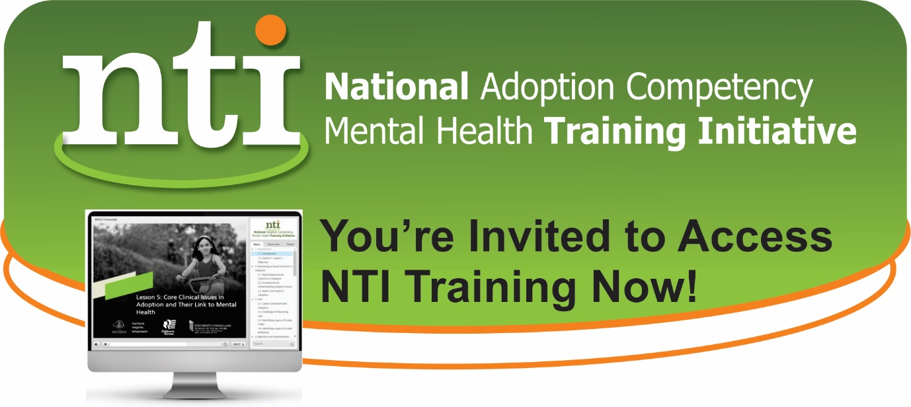

Enroll in National Adoption Competency Mental Health Training Initiative (NTI): Free web-based training with NASW approved CEUs!
NTI training enables you to better address the mental health & developmental needs of children in foster, adoptive or guardianship families is now ready for access! Enroll in NTI trainings for Child Welfare Professionals, Child Welfare Supervisors, and Mental Health Professionals. Join others from across the USA to “Advance Practice for Permanency and Well-Being!” Learn more: NTI website.

